- 2 x 3 rANOVA on gaze dir vs. action consistency

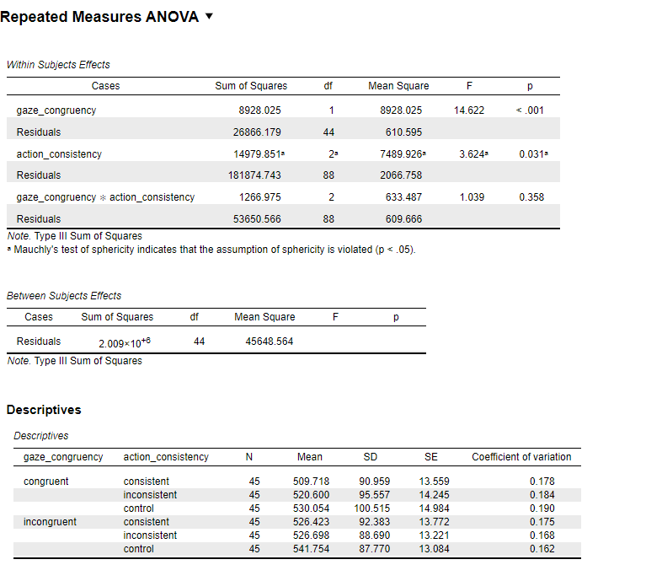

1. What analysis this is
You ran a 2 × 3 repeated-measures ANOVA with:
- gaze_congruency:
  - congruent vs incongruent
- action_consistency:
  - consistent, inconsistent, control
- DV: reaction time (RT)
- N = 45 participants (within-subjects)

2. Main effect of gaze congruency
F(1,44) = 14.62, p < .001
Meaning (plain language):
Participants respond significantly faster/slower depending on whether gaze is congruent or incongruent, regardless of action consistency.
This is a strong and reliable effect.
You can already see it in the means:
- Congruent RTs ≈ 510–530 ms
- Incongruent RTs ≈ 526–542 ms
👉 Incongruent gaze slows responses.

3. Main effect of action consistency
F(2,88) = 3.62, p = .031
(With sphericity violated → correction would normally be reported, but effect survives.)
Meaning:
RT differs across consistent vs inconsistent vs control actions, averaged over gaze.
Looking at the means:
- Consistent ≈ faster
- Inconsistent ≈ slower
- Control ≈ slowest – this is interesting – think why it happens
👉 Action predictability matters, but the effect is modest.

4. Interaction: gaze × action consistency – no interaction
F(2,88) = 1.04, p = .358
Meaning:
The effect of gaze congruency does NOT depend on action consistency.
In other words:
- Gaze congruency affects RT
- Action consistency affects RT
- But they do not amplify or cancel each other
The gaze effect is parallel across action conditions.

5. What the descriptives tell you (important)
From the table:
- In every action condition, incongruent gaze is slower than congruent
- The size of the gaze effect is similar across:
  - consistent
  - inconsistent
  - control
This visually explains why there is no interaction.

5. Why this is NOT a “null” or “bad” result
This result says something specific:
- Gaze processing is robust and automatic
- Action information adds a general processing cost
- But the two processes operate independently
This argues against strong integration of gaze and action at this stage of processing.
That is a theoretical result, not a failure.

6. Theoretical interpretation (very important)
Your results suggest two independent processes:
- Gaze processing
  - Automatic
  - Strong
  - Robust to action context
- Action consistency
  - Influences response preparation
  - Adds general processing cost
  - Does not modulate gaze cueing
👉 This supports a modular / additive model, not an interactive one.

7. How to summarize in one paragraph (thesis-ready)
A repeated-measures ANOVA revealed a significant main effect of gaze congruency, with slower responses for incongruent compared to congruent gaze cues. A significant main effect of action consistency was also observed, indicating differences in reaction times between consistent, inconsistent, and control actions. However, the interaction between gaze congruency and action consistency was not significant, suggesting that the effect of gaze congruency on reaction time was comparable across action conditions.

8. Key takeaway (one sentence)
Gaze congruency robustly affects attention, action consistency affects general response speed, but the two operate independently.
If you want, next we can:
- link this directly to social cognition theory, or
- discuss why this is still a meaningful result despite no interaction, or
- plan follow-up analyses (e.g., individual differences, covariates).
Just tell me where you want to go next.

- 3 levels rANOVA on effect size – I calculated effect size (effects mean) for action consistency by substract congruent cons/incons/control from incongruent cons/incons/control.

This is an excellent conceptual question, and you’re right to pause here.
I’ll explain it slowly, simply, and in meaning terms, not math.

Short answer first (intuition)
Nothing “new” is being tested statistically —
you are re-expressing the same data to answer a more focused question.
The difference is what the effects mean.

1. What the 2 × 3 repeated-measures ANOVA means
Your original 2 (gaze congruency) × 3 (action consistency) rANOVA asks:
- Main effect of gaze congruency
→ Are responses different for congruent vs incongruent on average?
- Main effect of action consistency
→ Are some action contexts generally faster/slower than others?
- Interaction
→ Does the difference between congruent and incongruent depend on action context?
So the interaction is already about gaze cueing — but indirectly.
💡 Important:
In this model, overall RT differences and cueing effects are mixed together.

2. What the “3-level ANOVA on difference scores” means
When you subtract:
RT(incongruent) − RT(congruent)
you are doing something psychologically meaningful:
“How strong is the gaze-cueing effect for each action context?”
Now your 3-level RM ANOVA asks only one question:
Does the size of gaze cueing differ between:
- consistent
- inconsistent
- control?
This is exactly the interaction, but isolated and simplified.

3. What is different conceptually (this is the key)
In the 2 × 3 rANOVA:
- RT level differences matter
- Fast vs slow subjects matter
- Main effects exist alongside the interaction
- Interpretation is multi-layered
In the difference-score ANOVA:
- Overall speed is removed
- Only within-subject contrasts remain
- The DV is now “attention shift strength”, not RT
- Interpretation is one-dimensional and clean

4. Are they statistically equivalent?
Yes, in theory.
The 3-level ANOVA on difference scores is mathematically related to the interaction term in the 2 × 3 ANOVA.
But in practice:
- The difference-score model is easier to interpret
- Less sensitive to baseline differences
- Often clearer for readers

5. Why researchers still report both
Typical structure in papers:
- 2 × 3 rANOVA
→ establishes overall effects and interaction
- Follow-up analysis on difference scores
→ explains how the interaction works
They are not redundant — they serve different explanatory roles.

6. Simple real-world analogy
Imagine measuring reaction time is like measuring walking speed.
- The 2 × 3 ANOVA asks:
Are people faster on flat ground vs uphill, and does terrain matter?
- The difference-score ANOVA asks:
How much does uphill slow people down in each terrain?
Same data — different focus.

7. One-sentence takeaway
👉 The 2 × 3 rANOVA asks “Are there differences and interactions in RT?”
👉 The 3-level ANOVA on difference scores asks “Does action context change the strength of gaze cueing itself?”
If you want, I can help you phrase this perfectly for a Methods / Results section or tell you which one reviewers usually prefer.

Short answer:
Because the second analysis focuses directly on the size of the gaze-cueing effect, while the 2×3 rANOVA interaction tests it indirectly and can miss small but meaningful differences.
In other words:
the interaction asks “is the pattern different overall?”,
the difference-score ANOVA asks “how strong is cueing in each condition?” — even if those differences are subtle.

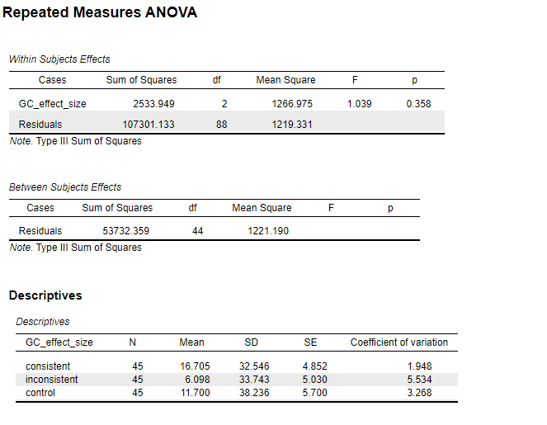

1. What analysis this is
You ran a one-way repeated-measures ANOVA (3 levels) on GC_effect_size.
- DV: GC_effect_size (your gaze-cueing effect, i.e., a difference score)
- Within-subject factor: action/gaze consistency
  - consistent
  - inconsistent
  - control
So you are asking:
Does the size of the gaze-cueing effect differ depending on action/gaze consistency?

2. The main result (the important line)
Within-Subjects Effects
GC_effect_size
- F(2, 88) = 1.039
- p = .358
Interpretation (simple):
👉 No significant difference in gaze-cueing effect size across the three conditions.
In everyday terms:
The gaze-cueing effect is numerically different, but not reliably different across consistent, inconsistent, and control conditions.

3. What the means tell you (descriptives)
Condition | Mean GC effect | What it means
consistent | 16.7 ms | Largest cueing effect
inconsistent | 6.1 ms | Smallest cueing effect
control | 11.7 ms | In between
Interpretation:
- Cueing looks strongest when action & gaze are consistent
- Weakest when inconsistent
- But the variability is large (SD ≈ 33–38 ms)
👉 These differences are too noisy to be statistically reliable.

4. Why this matches your 2×3 rANOVA result
Earlier:
- No interaction in the 2×3 rANOVA
Now:
- No effect of condition on GC effect size
These are the same conclusion expressed differently:
- 2×3 interaction asks:
Does gaze congruency behave differently across conditions?
- Difference-score ANOVA asks:
Is the gaze-cueing effect larger in some conditions than others?
Both say: No
✅ This is consistency, not a failure.

5. Why this analysis was still worth doing
Even though it’s nonsignificant, it:
- Tests your theoretical question directly
- Produces interpretable effect sizes
- Is easier to explain in a thesis
You can now say:
“Although gaze-cueing effects were numerically larger in the consistent condition, a repeated-measures ANOVA on gaze-cueing difference scores showed no significant effect of action–gaze consistency.”
That’s clean and defensible.

6. One-sentence takeaway (for your Results section)
A repeated-measures ANOVA on gaze-cueing effect sizes revealed no significant differences between consistent, inconsistent, and control conditions, F(2, 88) = 1.04, p = .36, indicating that action–gaze consistency did not reliably modulate the magnitude of the gaze-cueing effect.
If you want, next I can help you:
- write this exactly in APA style, or
- interpret this theoretically for social cognition (mirror system, prediction, etc.)

- Bin analysis

Here is a simple, short, bin-by-bin interpretation, focusing only on what changes over time.

Big picture (one sentence)
Gaze cueing is present in all bins; action consistency becomes important later, but it never truly interacts with gaze.

Bin-by-bin (very simple)
Bin 1 (earliest)
- ✔️ Gaze effect (congruent faster than incongruent)
- ❌ No action effect
- ❌ No interaction
👉 Early processing is pure gaze-driven.

Bin 2
- ✔️ Gaze effect
- ❌ No action effect
- ❌ No interaction
👉 Still mostly gaze-driven, action not yet relevant.

Bin 3
- ✔️ Gaze effect
- ⚠️ Action effect trend (p = .088, not significant)
- ❌ No interaction
👉 Action may start to matter, but evidence is weak.

Bin 4
- ✔️ Gaze effect
- ✔️ Action effect
- ❌ No interaction
👉 Both gaze and action affect RTs, independently.

Bin 5 (latest)
- ✔️ Gaze effect
- ✔️ Strong action effect
- ❌ No interaction
👉 Late responses are influenced by both gaze and action, but one does not change the effect of the other.

One clean interpretation sentence (for thesis)
Gaze cueing was robust across all time bins, while action consistency effects emerged only in later bins, suggesting a temporal dissociation between early gaze-driven orienting and later action-related processing.

Here is a clean, thesis-ready Results paragraph, followed by a short theory connection written in simple, clear language.

Results (time-bin analysis)
To examine the temporal dynamics of gaze and action processing, reaction times were divided into five consecutive time bins, and separate repeated-measures ANOVAs were conducted for each bin with gaze congruency (congruent vs. incongruent) and action consistency (consistent, inconsistent, control) as within-subject factors. Across all five bins, a significant main effect of gaze congruency was observed, with faster responses for gaze-congruent compared to gaze-incongruent trials. In the first two bins, no significant effects of action consistency were found, indicating that early responses were driven primarily by gaze information. In the third bin, the effect of action consistency approached significance but did not reach the conventional threshold. In contrast, significant main effects of action consistency emerged in the fourth and fifth bins, reflecting slower responses in the inconsistent condition relative to the consistent and control conditions. Importantly, no significant interactions between gaze congruency and action consistency were observed in any of the five bins, suggesting that the effects of gaze and action unfolded independently over time.

Interpretation: social vs. motor prediction
These results suggest a temporal dissociation between social and motor predictive processes. The robust gaze congruency effect across all bins indicates that gaze-based attentional orienting operates early and remains stable over time, consistent with accounts of gaze cueing as a fast, automatic social attention mechanism. In contrast, the delayed emergence of action consistency effects implies that action prediction relies on slower, more effortful processing, likely involving the integration of observed action cues with internal motor representations. The absence of gaze × action interactions further suggests that gaze and action information are processed in parallel rather than being integrated into a single predictive mechanism. Together, these findings support models in which social attention (gaze) guides early orienting, while motor prediction contributes at later stages of response preparation.

If you want, next I can:
- tighten this into a journal-style Results section
- help you write a Discussion paragraph
- help you link this to predictive coding or mirror neuron accounts

- Times correlation – only active conditions

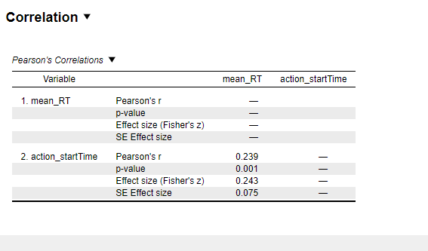

Simple interpretation of your correlation result:
- There is a small but statistically significant positive correlation between action start time and mean RT
→ r = .239, p = .001.
- This means that later gaze movement onset is associated with slower target responses.
- The effect size is small (Fisher’s z ≈ 0.24), so the relationship is reliable but not strong.
Conceptually:
- When the gaze starts moving earlier, participants tend to respond faster to the target.
- This supports the idea that temporal predictability of gaze/action facilitates attention and motor preparation, consistent with motor prediction mechanisms, rather than purely static social cueing.
What it does not mean:
- It does not imply causality.
- It does not say this effect is the same across all conditions (you should check correlations separately for consistent, inconsistent, and control).
One-line takeaway:
Earlier gaze/action timing modestly but reliably speeds up target responses.

- Times correlation – all conditions

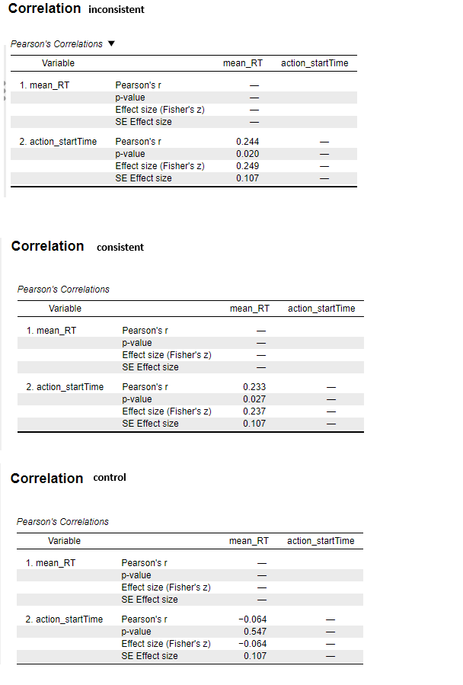

Here’s a clear, simple interpretation of the three correlations, tied to your design and theory 👇

Inconsistent action condition
- r = .244, p = .020
- Small but significant positive correlation
- Later gaze movement → slower target RTs
Meaning:
Even when the action–gaze relationship is unreliable, timing still matters. Participants use the temporal information of the gaze shift, consistent with motor prediction, but efficiency is reduced.

Consistent action condition
- r = .233, p = .027
- Small but significant positive correlation
- Earlier gaze movement → faster target RTs
Meaning:
When gaze follows the action predictably, participants benefit from accurate motor-based temporal prediction. This supports the idea that action-linked gaze timing facilitates attentional orienting.

Control condition
- r = −.064, p = .547
- No significant relationship
Meaning:
Because gaze onset is random, its timing carries no predictive value. Participants cannot use it to prepare responses, so no coupling between gaze timing and RT emerges.

Big picture (important)
- Correlations appear only when gaze timing is action-dependent
- They disappear when gaze timing is random
➡️ This pattern strongly supports motor prediction mechanisms over purely social cueing:
- Social cueing alone would predict effects even in control
- Motor prediction predicts timing-dependent coupling only in action conditions

One-sentence takeaway (thesis-ready)
Target responses scaled with gaze onset timing in both action conditions, but not in control, indicating that motor-based temporal prediction—rather than social cueing per se—drives performance.

- ANCOVA (controlling for start time) in correlations_all file

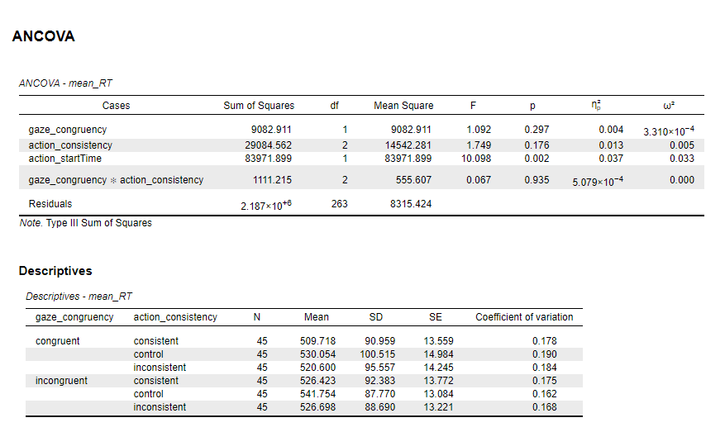

Here’s a clear, step-by-step explanation of your ANCOVA on mean reaction time (mean_RT).

1. What model was tested
- Dependent variable: mean_RT
- Factors (independent variables):
  - gaze_congruency (congruent vs. incongruent)
  - action_consistency (consistent, control, inconsistent)
- Covariate: action_startTime
- Interaction tested: gaze_congruency × action_consistency
- Type III sums of squares (appropriate for unbalanced designs or when interactions are included)

2. Main ANCOVA results
a) Gaze congruency
- F(1, 263) = 1.092, p = .297
- ηp² = .004 (very small effect)
Interpretation:
There is no significant effect of gaze congruency on reaction time after controlling for action start time. Congruent and incongruent gaze conditions do not differ reliably in mean RT.

b) Action consistency
- F(2, 263) = 1.749, p = .176
- ηp² = .013 (small effect)
Interpretation:
There is no significant main effect of action consistency on reaction time. RTs do not significantly differ between consistent, control, and inconsistent action conditions once the covariate is accounted for.

c) Covariate: Action start time
- F(1, 263) = 10.098, p = .002
- ηp² = .037 (small-to-moderate effect)
Interpretation:
Action start time significantly predicts reaction time.
Participants’ RTs systematically vary with when the action starts, justifying its inclusion as a covariate.

d) Interaction: Gaze congruency × Action consistency
- F(2, 263) = 0.067, p = .935
- ηp² ≈ 0
Interpretation:
There is no interaction effect. The influence of action consistency on RT does not depend on whether gaze is congruent or incongruent.

3. Descriptive statistics (raw means)
Although not statistically significant, the descriptives show trends:
- Congruent gaze
  - Fastest: consistent (≈ 510 ms)
  - Slowest: control (≈ 530 ms)
- Incongruent gaze
  - Fastest: consistent (≈ 526 ms)
  - Slowest: control (≈ 542 ms)
Across both gaze conditions:
- Consistent actions tend to be faster
- Control conditions tend to be slower
But these differences do not reach statistical significance after controlling for the covariate.

4. Overall conclusion (ready to report)
An ANCOVA on mean reaction time revealed a significant effect of action start time, F(1, 263) = 10.10, p = .002, ηp² = .037. Neither gaze congruency, F(1, 263) = 1.09, p = .297, nor action consistency, F(2, 263) = 1.75, p = .176, showed significant main effects. The interaction between gaze congruency and action consistency was also not significant, F(2, 263) = 0.07, p = .935.
If you want, I can:
- Help you write this in APA style
- Interpret it in relation to specific hypotheses
- Check ANCOVA assumptions (homogeneity of regression slopes, etc.)

